Privacy Notice
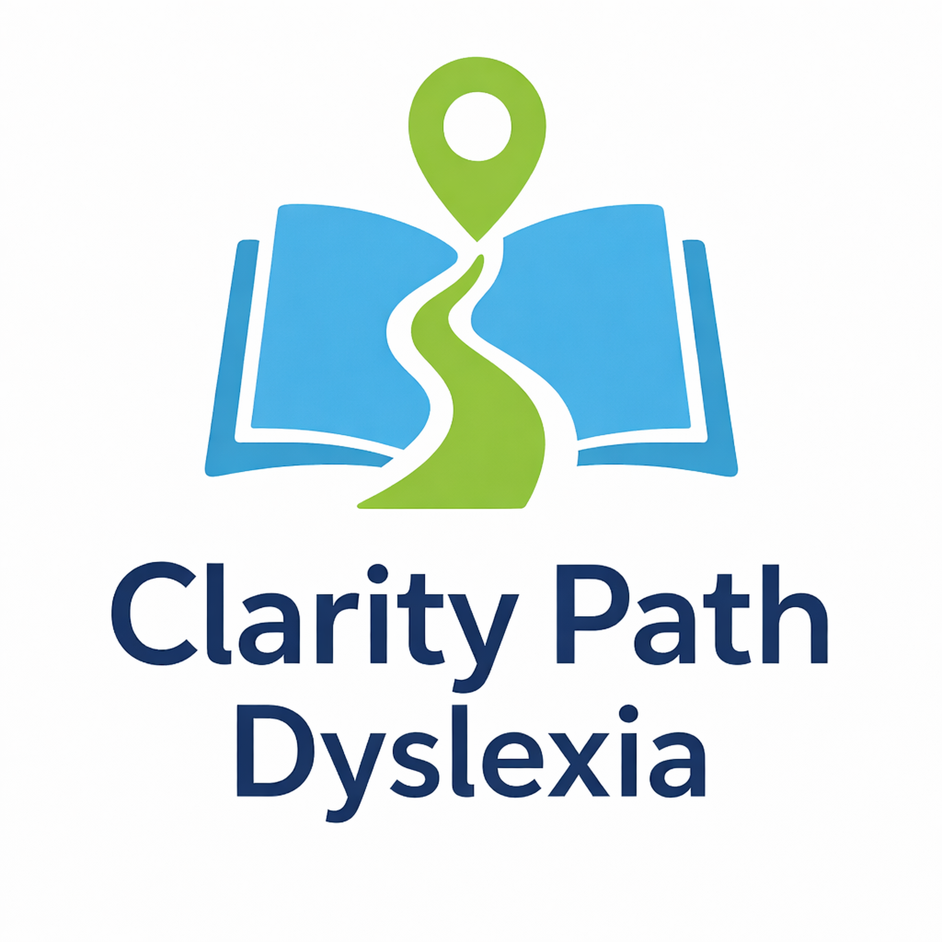

Information About Us
Clarity Path Dyslexia provides assessments for Specific Learning Difficulties for children.
Company Registration number:
Data protection Office:
Data Protection Registration Certificate:
Email address
Registered Office address:
Telephone:

Overview
At Clarity Path Dyslexia, we take your privacy seriously and are committed to handling personal information with care and respect. Any personal data shared with us—whether by email, phone, text, post or through our website—is treated as confidential.

We collect only the information necessary to provide our assessment services and to communicate with you effectively. Personal data is used solely for the purpose of delivering agreed services and supporting your child’s assessment. Robust measures are in place to keep information secure while it is stored, accessed and processed.

Information is never shared with third parties unless there is a clear and lawful reason to do so, or where consent has been given. Full details of any such circumstances are outlined within this policy.

You have the right to request access to the personal data we hold about you or your child, and to ask for information to be corrected or deleted where appropriate. If you have any questions or concerns about how data is handled, please contact the Data Protection Officer using the details provided above.
Clarity Path Dyslexia is registered with the Information Commissioner’s Office (ICO) and complies with UK data protection legislation.
ICO Registration Number: XXXXX

What information do we need to collect?
Prior to an assessment taking place, you will be asked to complete a background questionnaire via Google Forms. Please see Google’s privacy policy.

We will collect the following information through conversation and online forms:
- Name (title, first and surname)
- Home address
- Email address
- Telephone number
- Medical / disability information
- Date of birth
- Genfer
- Background information about the child being assessed

Why do we need your data?
- To communicate with you as a response to an email, text or telephone query
- To provide you with any ongoing support required
- To collect payment for our services
- To comply with statutory requirements for book keeping, auditing and accounting.

How do we store you data?
When you use our services, any personal information we collect may be stored electronically and/or in paper form. Digital records are held securely using encrypted cloud-based storage, and documents containing sensitive information, such as assessment reports, are protected with passwords.

Where paper records are required, these are kept in a locked, fire-resistant filing system with restricted access.

Information is shared electronically only when necessary and appropriate safeguards are in place. Password protection is used whenever sensitive or confidential data is transferred by email or secure file-sharing methods.
We use GDPR-compliant systems to support secure data storage. These providers do not access, use or share your personal information and act only as secure data processors.

How do we share your data?
Your data and any associated report will not be shared with anyone other than yourself. Once you engage a third party (for example; the child’s school or a private tutor) Clarity Path Dyslexia cannot be held responsible for any data breaches that occur due to their handling of your personal information.

How long do we keep your data?
We retain assessment records and related documentation only for as long as it is necessary and appropriate, in accordance with legal requirements and guidance from relevant professional and regulatory bodies. These retention periods are reviewed and may be updated over time.

Currently, digital copies of assessment reports for children and young people are securely stored until the individual reaches 25 years of age. Original assessment materials and test papers are confidentially destroyed once the report has been completed and formally agreed.

Background information provided as part of the assessment process is held for a limited period. Online working documents are removed within one month, and secure PDF copies are retained alongside the final report where required for record-keeping purposes.

How can you get access to your personal data?
You are entitled to ask what personal information we hold about you or your child and to request a copy of this information. This is often referred to as a subject access request.

If you would like to make a request, please contact the Data Protection Officer using the details provided at the start of this policy. You will be asked to complete a short request form to help us process this securely.

There is no fee for making a reasonable request. We aim to respond within one month, although in certain circumstances—such as more complex requests—this may take longer, up to a maximum of three months.

Complaints
Please contact us in the first instance with any questions or complaints you may have.

Updates to privacy policy
This privacy policy may be updated from time to time to reflect changes in legislation, guidance or how we operate. We recommend checking this page occasionally to stay informed about how personal information is handled.
Any updates will take effect as soon as the revised policy is published on our website. Where significant changes are made, we will clearly indicate that the policy has been updated so you can understand what information is collected, how it is used and when it may be shared.

Further information about your data protection rights and our responsibilities under UK data protection legislation can be found on the Information Commissioner’s Office (ICO) website.

